**Title:** Healthcare Policy and Regulation Impact on Business

**Submitted By:**

**Student Name:** Abdulkalam Kadar Shaikh

**Enrolment No:** 22MBA07R0770

**Under Supervision of:**

**Swapnil Salunke (M. Tech)**



Submit­­­ted in partial fulfilment of the requirement for qualifying

**Program name:** MBA (Healthcare Management)

**Academic Year**:2023-24

**CERTIFICATE**

This is to certify that the project report titled **“Healthcare Policy and Regulation Impact on Business”** being submitted by **Abdulkalam Kadar Shaikh**, in partial fulfilment of the requirements for the award of the Degree of Master of Business Administration, is a bonafide record of the project work done by **Abdulkalam Kadar Shaikh** of Symbiosis Skills and Professional University.

**Swapnil N. Salunke**

**DECLARATION**

I **Abdulkalam Kadar Shaikh** the undersigned solemnly declare that the report of the project work entitled **Healthcare Policy and Regulation Impact on Business** is based my own work carried out during the course of my study.

I assert that, the statements made and conclusions drawn are an outcome of the project work.

I further declare that to the best of my knowledge and belief that the project report does not contain any part of any work which has been submitted for the award of any other degree/diploma/certificate in this University or any other University.



(Signature of the Candidate) Abdulkalam Kadar Shaikh

**Acknowledgement**

First of all, I thank our almighty god sincerely for his presence which enabled me to finish this project successfully. I express my deep sense of gratitude to Prof. S. K. Sarangi, My Project guide, for his guidance during my project work and sparing his valuable time and also for his constant encouragement throughout my project report.

I would also like to thank my parents and friends for their help and support and motivating me for the successful completion of this project report

**Executive Summary**

The intersection of healthcare policy and regulation with business practices is a critical area that significantly affects the operational, financial, and strategic decisions of organizations within the healthcare sector. This report examines the impact of healthcare policies and regulations on businesses, highlighting the challenges and opportunities that arise from the evolving regulatory landscape. Healthcare policies, including laws like the Affordable Care Act (ACA) in the United States, have far-reaching implications for businesses. These regulations dictate the standards for healthcare delivery, insurance coverage, patient privacy, and the pricing of medical services. Compliance with these policies is mandatory, and non-compliance can result in significant legal and financial penalties.

The regulatory environment requires businesses to continuously adapt to new rules, such as those concerning electronic health records (EHRs), data security under the Health Insurance Portability and Accountability Act (HIPAA), and value-based care initiatives. These regulations often necessitate substantial investments in technology, staff training, and operational restructuring. Moreover, healthcare regulations influence market dynamics by affecting the cost of healthcare services, the competitive landscape, and the entry barriers for new players. Businesses must navigate these regulations while balancing cost efficiency with quality care delivery. This report also explores how businesses can leverage regulatory changes to innovate and gain competitive advantages.

In conclusion, understanding and effectively managing the impact of healthcare policies and regulations is vital for business success in the healthcare sector. Companies that proactively engage with regulatory changes and integrate compliance into their strategic planning are better positioned to thrive in this complex and highly regulated environment. The research on healthcare policies and regulations offers a detailed examination of the current healthcare landscape, revealing several critical findings and recommendations. The study identifies significant gaps and inefficiencies in existing policies, such as inadequate coverage for certain populations and fragmented care systems, highlighting the urgent need for comprehensive policy reform. Financial burdens on patients and healthcare organizations were found to be substantial, pointing to the necessity for effective cost-management strategies and financial support mechanisms to alleviate these challenges. Disparities in healthcare access and quality among different demographic groups were also revealed, emphasizing the need for targeted interventions to promote health equity and ensure that all individuals have access to quality care.

Additionally, the research uncovered challenges related to regulatory compliance, where complex requirements create administrative burdens and inefficiencies in care delivery. Simplifying these regulatory processes and providing better support for compliance are essential to improving operational efficiency. Patient safety concerns were identified, with high rates of medical errors and gaps in safety protocols highlighting the need for stronger safety measures and improved protocols. The study assessed the effectiveness of existing policies, finding that some are not achieving their intended outcomes, suggesting that evidence-based adjustments are necessary to better meet healthcare goals.

The integration of new technologies, such as electronic health records and telemedicine, has significantly impacted healthcare delivery. While these technologies offer benefits, challenges such as adoption barriers and data security need to be addressed. Insights from stakeholders, including healthcare providers, patients, and policymakers, provided valuable perspectives on the strengths and weaknesses of current policies, underscoring the importance of incorporating this feedback into policy refinement. Finally, the study highlighted substantial administrative and compliance burdens faced by healthcare organizations, impacting their efficiency and quality of care. Recommendations include implementing comprehensive policy reforms, developing cost-management strategies, introducing equity initiatives, streamlining regulatory processes, strengthening safety measures, adjusting policies based on evidence, addressing technology integration challenges, and reducing administrative burdens. These recommendations aim to enhance the healthcare system, improve care delivery, and achieve better patient outcomes. The research on healthcare policies and regulations offers a detailed examination of the current healthcare landscape, revealing several critical findings and recommendations. The study identifies significant gaps and inefficiencies in existing policies, such as inadequate coverage for certain populations and fragmented care systems, highlighting the urgent need for comprehensive policy reform. Financial burdens on patients and healthcare organizations were found to be substantial, pointing to the necessity for effective cost-management strategies and financial support mechanisms to alleviate these challenges. Disparities in healthcare access and quality among different demographic groups were also revealed, emphasizing the need for targeted interventions to promote health equity and ensure that all individuals have access to quality care.

Additionally, the research uncovered challenges related to regulatory compliance, where complex requirements create administrative burdens and inefficiencies in care delivery. Simplifying these regulatory processes and providing better support for compliance are essential to improving operational efficiency. Patient safety concerns were identified, with high rates of medical errors and gaps in safety protocols highlighting the need for stronger safety measures and improved protocols. The study assessed the effectiveness of existing policies, finding that some are not achieving their intended outcomes, suggesting that evidence-based adjustments are necessary to better meet healthcare goals.

The integration of new technologies, such as electronic health records and telemedicine, has significantly impacted healthcare delivery. While these technologies offer benefits, challenges such as adoption barriers and data security need to be addressed. Insights from stakeholders, including healthcare providers, patients, and policymakers, provided valuable perspectives on the strengths and weaknesses of current policies, underscoring the importance of incorporating this feedback into policy refinement. Finally, the study highlighted substantial administrative and compliance burdens faced by healthcare organizations, impacting their efficiency and quality of care. Recommendations include implementing comprehensive policy reforms, developing cost-management strategies, introducing equity initiatives, streamlining regulatory processes, strengthening safety measures, adjusting policies based on evidence, addressing technology integration challenges, and reducing administrative burdens. These recommendations aim to enhance the healthcare system, improve care delivery, and achieve better patient outcomes.

**Table of Contents**

|  |  |  |
| --- | --- | --- |
| **Sr no.** | **Title** | **Page no** |
| 1) | Front page | i |
| 2) | Certificate | ii |
| 3) | Declaration by Learner | iii |
| 4) | Acknowledgement | iv |
|  | **Chapters** |  |
| 5) | Executive Summary | 1-3 |
| 6) | Table of Contents | 4 |
| 7) | **Chapter One**  Introduction – origin, essentials of the main subject.  Justification of the Project problems  Project Objectives | 5-21 |
| 8) | **Chapter Two**  Designing Project Plan and Methodology  Tools and techniques for Data Collection | 22-31 |
| 5) | **Chapter Three**  Analysis and Interpretation  Major Findings | 32-45 |
| 9) | **Chapter Four**  Conclusions, Recommendations, and Suggestions | 46-49 |
| 10) | References and Bibliography | 50-51 |
| 11) | Appendices | 52-62 |

Chapter One

**Origin and Essentials of Healthcare Policy and Regulation**

**Origin:** Healthcare policy and regulation have undergone significant transformation over the past century, reflecting the changing needs and challenges of the healthcare system. The origins of modern healthcare policy can be traced back to early 20th-century reforms aimed at addressing public health issues and improving medical standards. Initially, these policies focused on combating infectious diseases and ensuring basic healthcare access for underserved populations. The establishment of government-funded healthcare programs, such as Medicare and Medicaid in the United States in 1965, marked a pivotal shift in healthcare policy, introducing a formal structure for government involvement in healthcare coverage. These programs were designed to provide essential healthcare services to the elderly and low-income individuals, respectively, and have since become fundamental components of the U.S. healthcare system.

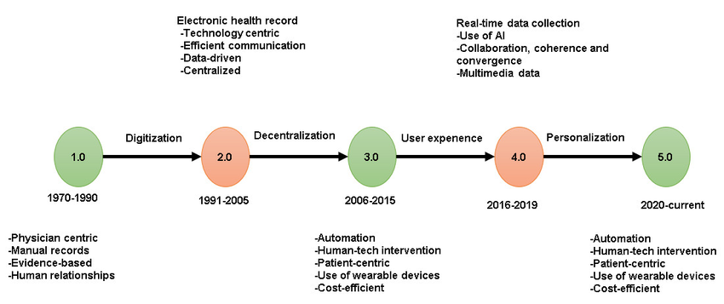

**Image 1.1**

In recent decades, healthcare policies have continued to evolve in response to a variety of factors, including technological advancements, demographic changes, and increased awareness of healthcare disparities. The passage of the Affordable Care Act (ACA) in 2010 represents a landmark moment in healthcare policy, with comprehensive reforms aimed at expanding access to healthcare, improving quality, and controlling costs. This legislation introduced significant changes, including the establishment of health insurance marketplaces, the expansion of Medicaid eligibility, and requirements for coverage of essential health benefits. In recent years, healthcare policy and regulation have continued to evolve in response to emerging challenges.

COVID-19 pandemic, which highlighted the need for robust public health responses and telehealth services. Recent legislative efforts have focused on enhancing access to care, addressing healthcare disparities, and incorporating advances in technology and data analytics. While the focus here has been on U.S. healthcare policy, it is important to acknowledge that healthcare regulation and policy have different origins and developments in other parts of the world. For example, many European countries have long-established universal healthcare systems that have influenced global healthcare policy discussions.

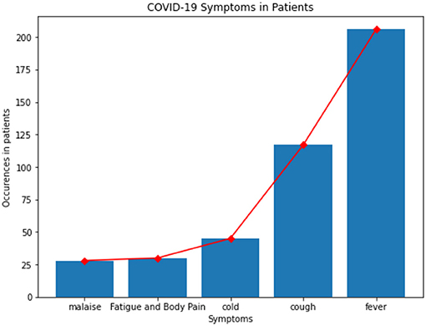

**Image 1.2**

It is important to acknowledge that healthcare regulation and policy have different origins and developments in other parts of the world. For example, many European countries have long-established universal healthcare systems that have influenced global healthcare policy discussions.

**Essentials of Healthcare Policy and Regulation:**

Healthcare policy and regulation are critical components of the healthcare system, encompassing a wide range of laws, guidelines, and standards that govern the delivery, financing, and management of healthcare services. Understanding these essentials is crucial for businesses operating in the healthcare sector, as they directly impact their operations and strategic decisions.

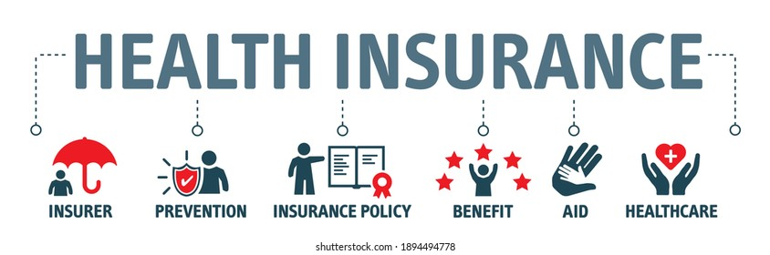

**Image 1.3**

Key Components of Healthcare Policy

* **Access to Care:** One of the central components of healthcare policy is ensuring that all individuals have access to necessary medical services. This includes policies that expand health insurance coverage, support community health programs, and address barriers to care for underserved populations.
* **Quality of Care:** Policies and regulations focus on maintaining and improving the quality of healthcare services. This involves setting standards for clinical practices, accrediting healthcare facilities, and implementing quality improvement initiatives. Quality of care policies often include mechanisms for monitoring and evaluating healthcare outcomes.
* **Cost Control:** Controlling healthcare costs is a significant aspect of policy-making. Policies in this area may involve regulating prices for medical services and pharmaceuticals, promoting cost-effective care practices, and managing healthcare spending through various funding mechanisms, such as public insurance programs. medical services and pharmaceuticals, promoting cost-effective care practices, and managing healthcare spending through various funding mechanisms, such as public insurance programs
* **Healthcare Workforce:** Policies related to the healthcare workforce address issues such as training, certification, and continuing education for healthcare professionals. These policies ensure that the workforce is adequately prepared to meet the demands of the healthcare system and provide high-quality care.
* **Health Promotion and Disease Prevention:** Policies aimed at health promotion and disease prevention focus on educating the public, encouraging healthy behaviours, and implementing preventive measures. These policies can include vaccination programs, anti-smoking campaigns, and initiatives to promote healthy lifestyles.
* **Patient Rights and Safety:** Ensuring patient rights and safety is a critical component of healthcare policy. Regulations in this area protect patients' rights to informed consent, privacy, and safe treatment. They also address issues related to medical malpractice and patient advocacy.
* **Legislation**: Healthcare legislation sets the framework for the provision and financing of healthcare services. Significant laws, such as the ACA, address issues like health insurance coverage, preventive care, and consumer protections. These laws shape the regulatory environment within which businesses operate.
* **Regulatory Bodies**: Various agencies oversee the implementation and enforcement of healthcare regulations. For example, the centres for Medicare & Medicaid Services (CMS) administers Medicare and Medicaid programs.
* **Compliance Requirements**: Businesses must adhere to numerous compliance requirements, including those related to patient privacy (e.g., Health Insurance Portability and Accountability Act or HIPAA), electronic health records (EHRs), and quality reporting. Compliance is essential to avoid legal penalties and ensure high standards of care.
* **Market Dynamics**: Healthcare regulations impact market dynamics by influencing competition, pricing, and reimbursement policies. Regulations such as those governing insurance reimbursement rates and cost containment measures affect how businesses interact with payers and patients.

**Key Components of Healthcare Regulation:**

These frameworks are crucial for addressing complex healthcare challenges, such as managing chronic diseases, responding to public health emergencies, and advancing medical research.

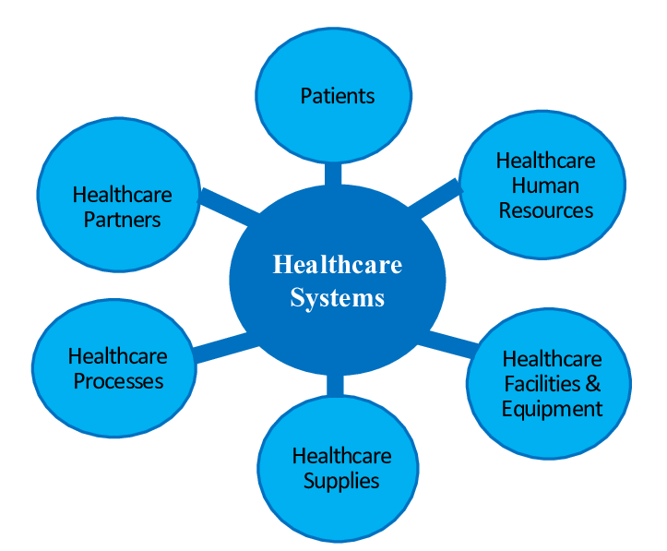

**Image 1.4**

1. **Licensing and Accreditation:** Healthcare regulations establish requirements for licensing and accreditation of healthcare providers and facilities. This ensures that providers meet minimum standards of competence and that facilities are equipped to deliver safe and effective care.
2. **Compliance and Enforcement:** Regulations include mechanisms for monitoring compliance with established standards and taking enforcement actions when necessary. This can involve regular inspections, audits, and penalties for non-compliance.
3. **Data Reporting and Transparency:** Regulations often require healthcare organizations to report data related to care quality, patient outcomes, and financial performance. This promotes transparency and allows for informed decision-making by policymakers, patients, and other stakeholders.
4. **Pharmaceutical Regulation:** The regulation of pharmaceuticals involves oversight of drug development, approval, and marketing. Regulatory agencies ensure that medications are safe, effective, and marketed accurately. This includes monitoring for adverse effects and managing drug recalls.
5. **Health Information Technology:** Regulations related to health information technology govern the use of electronic health records (EHRs), health information exchanges, and telemedicine. These regulations aim to protect patient data, ensure interoperability, and support the efficient use of technology in healthcare delivery.
6. **Fraud and Abuse Prevention:** Regulations address issues related to fraud and abuse in the healthcare system. This includes measures to prevent fraudulent billing practices, misuse of public funds, and other forms of exploitation.

Healthcare policy refers to decisions, goals, and strategies developed by governmental bodies or organizations that guide the provision and management of healthcare services. These policies aim to improve public health, ensure equitable access to care, and enhance the overall quality of the healthcare system. Healthcare regulations, on the other hand, are specific rules and standards established to implement these policies. They govern the behavior of healthcare providers, institutions, and businesses, ensuring compliance with established standards. The primary purposes of healthcare policy and regulation include safeguarding public health, reducing disparities in healthcare access, controlling costs, ensuring the safety and quality of care, and protecting the rights of patients. These frameworks are crucial for addressing complex healthcare challenges, such as managing chronic diseases, responding to public health emergencies, and advancing medical research.

**Justification of the Project problems**

The justification for exploring the impact of healthcare policies and regulations on business stems from the critical role that healthcare policies play in shaping the operational and financial landscapes of various industries. Businesses, across sectors such as insurance, pharmaceuticals, healthcare services, and technology, are profoundly affected by regulatory changes and policy implementations. Understanding these impacts is essential for several reasons. First, healthcare regulations can significantly influence operational costs, compliance requirements, and strategic planning, affecting a business’s profitability and market position. For instance, changes in health insurance regulations can alter the cost structure for companies providing employee benefits, impacting their financial stability and competitive edge. Second, the dynamic nature of healthcare policies means that businesses must continuously adapt to new regulations, which can create both opportunities and challenges. An in-depth analysis can help businesses anticipate regulatory changes, adapt their strategies accordingly, and leverage opportunities for innovation or market expansion. This proactive approach is crucial for maintaining compliance and gaining a competitive advantage. Furthermore, understanding the impact of healthcare regulations is essential for policymakers and industry leaders to develop more effective and balanced policies. By analysing how existing policies affect various sectors, the project can provide valuable insights into potential areas for policy improvement or reform. This, in turn, can contribute to more effective regulation that supports both business growth and public health objectives.

Overall, the justification for this project lies in its potential to provide a comprehensive understanding of how healthcare policies and regulations influence business operations. This understanding is crucial for businesses to navigate regulatory environments successfully, for policymakers to craft informed regulations, and for stakeholders to align their strategies with evolving healthcare landscapes. Justifying the problems associated with a project involves demonstrating the significance and relevance of the issues being addressed. This process provides a rationale for why the project is necessary, outlining the underlying problems and their impact on stakeholders. For a project in the healthcare sector, such as one focusing on healthcare policy and regulation or any other specific aspect, justifying the problems involves several key steps. For a project in the healthcare sector, such as one focusing on healthcare policy and regulation or any other specific aspect, justifying the problems involves several key steps:

**Identifying the Core Problems**

To justify the project problems, begin by clearly identifying the core issues that the project aims to address. These problems often stem from gaps or deficiencies in the current system, such as:

* **Inefficiencies in Healthcare Delivery:** Problems may include delays in care, fragmented services, or inadequate coordination between different healthcare providers.
* **High Costs and Inequities:** Rising healthcare costs and disparities in access to care can impact underserved populations and strain public resources.
* **Regulatory Challenges:** Navigating complex regulations, compliance issues, and frequent changes in policy can pose significant challenges for healthcare organizations.
* **Quality and Safety Concerns:** Issues related to the quality of care, patient safety, and adverse outcomes can undermine trust in the healthcare system.

**Analysing the Impact**

To justify these problems, analyse their impact on various stakeholders:

* **Patients:** Problems such as inefficiencies, high costs, or safety concerns directly affect patient outcomes and experiences. For example, delays in receiving care can lead to worsening health conditions, while high costs can limit access to necessary treatments.
* **Healthcare Providers:** Providers may face challenges related to regulatory compliance, financial pressures, or difficulties in coordinating care. These issues can affect their ability to deliver high-quality care and may contribute to burnout or dissatisfaction.
* **Healthcare Organizations:** Organizations may struggle with administrative burdens, financial constraints, or difficulties in meeting regulatory requirements. This can impact their operational efficiency and overall effectiveness.

**Providing Evidence**

Support the justification with evidence that highlights the severity and scope of the problems:

* **Data and Statistics:** Use relevant data to quantify the extent of the problems. For instance, statistics on healthcare costs, access disparities, or patient safety incidents can provide concrete evidence of the issues.
* **Case Studies:** Illustrate the problems through case studies or examples from real-world scenarios. This can help demonstrate how the issues manifest in practice and their impact on stakeholders.
* **Expert Opinions:** Incorporate insights from healthcare professionals, policymakers, or industry experts to validate the significance of the problems. Their perspectives can add credibility and depth to the justification.

**Demonstrating the Need for the Project**

Explain why the project is necessary to address the identified problems:

* **Gap Analysis:** Identify specific gaps in the current system that the project aims to address. This could include areas where existing policies or regulations fall short or where new solutions are needed.
* **Expected Outcomes:** Outline the anticipated benefits and outcomes of the project. For example, if the project aims to improve regulatory compliance, describe how this will enhance operational efficiency and reduce administrative burdens.
* **Alignment with Priorities:** Show how the project aligns with broader healthcare priorities or strategic goals. This could include improving patient care, reducing costs, or advancing public health objectives.

**Addressing Potential Solutions**

Justify the project by explaining how it offers viable solutions to the identified problems:

* **Innovative Approaches:** Highlight any innovative methods or technologies that the project will employ to address the problems effectively.
* **Evidence-Based Solutions:** If applicable, reference evidence-based practices or models that the project will incorporate to ensure its effectiveness.

For a project aimed at analysing the impact of healthcare policy and regulation on businesses, the justification might include:

1. **Core Problems:** Inefficiencies in compliance processes, financial burdens due to regulatory changes, and challenges in adapting to new policies.
2. **Impact Analysis:** The project affects healthcare businesses by potentially increasing operational costs, complicating compliance efforts, and impacting strategic planning.
3. **Evidence:** Data on compliance costs, case studies of regulatory challenges faced by healthcare businesses, and expert opinions on policy impacts.
4. **Need for Project:** The project is necessary to provide insights into the regulatory landscape, identify areas for improvement, and help businesses adapt to changes more effectively.
5. **Solutions:** The project will offer recommendations for streamlining compliance processes, reducing financial burdens, and improving adaptability to regulatory changes.

**Project Objectives**

Project objectives are critical in defining the purpose, scope, and outcomes of a project. They provide a clear roadmap for what the project aims to achieve and guide the planning, execution, and evaluation processes. For a project related to healthcare policy and regulation, the objectives should address the specific challenges and goals associated with the field. These objectives need to be precise, measurable, and aligned with the overall mission of improving healthcare systems. Below is a detailed explanation of the project objectives, encompassing various dimensions of a healthcare policy and regulation project.

**1. Improve Healthcare Policy Frameworks:**

One of the primary objectives of the project is to enhance the existing healthcare policy frameworks. This involves assessing current policies to identify gaps, inconsistencies, and areas needing reform. By reviewing and analysing existing policies, the project aims to propose updates or new frameworks that better address emerging healthcare challenges. Objectives in this area include:

* Conduct Comprehensive Policy Analysis: Perform a thorough review of current healthcare policies to evaluate their effectiveness, identify deficiencies, and understand their impact on various stakeholders. This analysis will help pinpoint areas where policies may be outdated or inadequate in meeting current healthcare needs.
* Propose Policy Reforms: Develop recommendations for policy reforms based on the analysis. These recommendations should aim to streamline processes, enhance efficiency, and address gaps in coverage or access. The goal is to create a more robust and responsive policy framework that aligns with contemporary healthcare priorities.
* Facilitate Stakeholder Consultation: Engage with key stakeholders, including healthcare providers, policymakers, and patient advocacy groups, to gather input on proposed policy changes. This consultation will ensure that the proposed reforms are practical, relevant, and supported by those who will be affected by them. to gather input on proposed policy changes. This consultation will ensure that the proposed reforms are practical, relevant, and supported by those who will be affected by them.

**2. Enhance Regulatory Compliance:**

Another crucial objective is to improve regulatory compliance within the healthcare sector. Healthcare organizations often face challenges in adhering to complex regulations, which can affect their operations and efficiency. Objectives related to enhancing regulatory compliance include:

* Develop Compliance Guidelines: Create clear and comprehensive guidelines for healthcare organizations to follow, ensuring they meet regulatory requirements. These guidelines should address key areas such as data privacy, safety standards, and reporting requirements.
* Implement Training Programs: Design and implement training programs for healthcare staff to improve their understanding of regulatory requirements and compliance procedures. Effective training will help ensure that staff are well-informed and capable of adhering to regulations, reducing the risk of non-compliance.
* Establish Monitoring and Auditing Mechanisms: Set up systems for ongoing monitoring and auditing of regulatory compliance. Regular audits and evaluations will help identify potential issues early and provide opportunities for corrective actions to be taken before problems escalate.

**3. Optimize Healthcare Delivery Systems**

Optimizing healthcare delivery systems is another key objective of the project. Efficient and effective delivery of healthcare services is essential for improving patient outcomes and reducing costs. Objectives in this area include:

* analyse Current Delivery Models: Evaluate existing healthcare delivery models to identify inefficiencies and areas for improvement. This analysis should focus on aspects such as care coordination, service integration, and patient flow.
* Implement Innovative Solutions: Propose and test innovative solutions to enhance healthcare delivery. This could include adopting new technologies, improving care coordination strategies, or implementing patient-centred care models. The goal is to streamline processes and improve overall service quality.

**4. Address Healthcare Cost Management**

Effective cost management is a critical objective in any healthcare project. Rising healthcare costs can have significant impacts on patients and organizations. Objectives related to cost management include:

* Identify Cost Drivers: Conduct an analysis to identify the primary drivers of healthcare costs within the system. This analysis should focus on areas such as resource utilization, administrative expenses, and treatment costs.
* Develop Cost-Reduction Strategies: Propose strategies to reduce healthcare costs without compromising quality of care. This could involve implementing cost-effective treatments, improving resource allocation, or reducing administrative overhead.
* Evaluate Financial Implications: Assess the financial implications of proposed cost-reduction strategies. Ensure that the strategies are feasible and sustainable in the long term, and evaluate their impact on both patient expenses and organizational finances.

**5. Improve Patient Safety and Quality of Care**

Enhancing patient safety and quality of care is a fundamental objective of any healthcare-related project. High standards of care are essential for achieving positive health outcomes and maintaining public trust. Objectives in this area include:

* Assess Current Safety Standards: Review existing safety standards and practices to identify areas for improvement. This assessment should focus on practices related to infection control, medication management, and patient monitoring.
* Develop Quality Improvement Initiatives: Design and implement initiatives to improve the quality of care. This could involve introducing new protocols, enhancing staff training, or adopting evidence-based practices.
* Monitor and Report Outcomes: Establish systems for monitoring patient safety and quality of care outcomes. Regular reporting and analysis will help track progress, identify trends, and ensure that quality improvement initiatives are effective.

**6. Promote Health Equity and Access:**

Promoting health equity and improving access to care are essential objectives in addressing disparities within the healthcare system. Objectives in this area include:

* Identify Disparities in Access: Conduct research to identify disparities in healthcare access among different populations. This could involve analysing data on access to services, insurance coverage, and health outcomes across various demographic groups.
* Develop Strategies to Enhance Access: Propose strategies to improve access to care for underserved populations. This could include expanding insurance coverage, increasing the availability of services in underserved areas, or implementing community-based health programs.
* Evaluate Impact on Health Equity: Assess the impact of implemented strategies on health equity. Measure improvements in access and outcomes among different populations to ensure that the strategies are effective in reducing disparities.

**7. Support Evidence-Based Decision Making:**

Supporting evidence-based decision-making is a crucial objective for ensuring that healthcare policies and practices are informed by the best available evidence. Objectives in this area include:

* Promote Research and Data Collection: Encourage the collection of high-quality data and research to inform decision-making. This includes supporting studies on healthcare outcomes, treatment effectiveness, and policy impacts.
* Facilitate Data Integration: Develop systems for integrating data from various sources to provide a comprehensive view of healthcare issues. This could involve creating databases or analytical tools that support evidence-based decision-making.
* Disseminate Findings and Best Practices: Share research findings and best practices with healthcare professionals, policymakers, and other stakeholders. Effective dissemination will help ensure that evidence-based approaches are widely adopted and implemented.

**Examine Historical and Contemporary Healthcare Policies:**

* **Objective:** Analyse the development and evolution of key healthcare policies and regulations from their inception to the present day.
* **Purpose:** To understand the foundational changes that have shaped the current regulatory environment and their long-term impacts on the healthcare sector.

**Evaluate the Impact on Business Operations:**

* Objective: Assess how healthcare regulations affect business operations, including compliance requirements, operational efficiency, and financial stability.
* Purpose: To identify how businesses must adapt their practices to meet regulatory demands and manage associated costs.

**Analyse Regulatory Effects on Market Dynamics:**

* **Objective:** Investigate how healthcare policies influence market competition, pricing strategies, and reimbursement mechanisms.
* **Purpose:** To understand the broader market implications of regulations and how they shape competitive dynamics and financial outcomes for businesses.

**Identify Key Challenges and Opportunities:**

* **Objective:** Identify and analyse the primary challenges businesses face due to regulatory changes and uncover potential opportunities for growth and innovation.
* **Purpose:** To provide businesses with insights into navigating regulatory obstacles and capitalizing on emerging opportunities.

**Assess the Role of Technology and Innovation:**

* **Objective:** Explore how healthcare regulations impact the adoption and integration of new technologies and innovative solutions.
* **Purpose:** To understand the regulatory influences on technological advancements and how businesses can leverage these developments to enhance their operations.

**Develop Strategic Recommendations:**

* **Objective:** Offer practical recommendations for businesses to effectively manage regulatory compliance, adapt to policy changes, and improve strategic positioning.
* **Purpose:** To provide actionable strategies that help businesses align with regulatory requirements while pursuing operational and strategic goals.

**Explore Future Trends and Their Implications:**

* **Objective:** Anticipate future trends in healthcare policy and regulation and evaluate their potential effects on the business landscape.
* **Purpose:** To prepare businesses for upcoming regulatory changes and their possible impacts on the industry.

**Conduct Case Studies**:

* **Objective:** Present case studies of various healthcare businesses to illustrate real-world examples of regulatory impact and responses.
* **Purpose:** To provide concrete examples that highlight successful strategies and lessons learned from navigating regulatory challenges.

**Compile and Analyse Data:**

* Objective: Gather and analyse relevant data from regulatory documents, industry reports, and stakeholder feedback.
* Purpose: To support the report’s findings with robust data and ensure accurate, evidence-based conclusions.

+

Chapter Two

**Designing Project Plan and Methodology**

To design a project plan and methodology for a report on "Healthcare Policy and Regulation Impact on Business," start by clearly defining the project's objectives. The primary goal is to assess how various healthcare policies and regulations impact different business sectors, identifying both challenges and opportunities. Secondary objectives include pinpointing specific policies affecting businesses, evaluating their sector-specific impacts, and offering actionable recommendations. The scope of the project encompasses a detailed analysis of major healthcare policies and regulations at both national and regional levels, with a focus on sectors such as insurance, pharmaceuticals, healthcare providers, and technology. Exclusions should include policies or sectors that do not directly influence business operations. The timeline for the project should be structured to ensure a thorough approach. Begin with a literature review and background research over the first two weeks, followed by data collection through surveys, interviews, and case studies in the third week. analyse the collected data and identify key findings during the fourth week, and draft the report, including analysis and recommendations, in the fifth week. The sixth week should be dedicated to reviewing and revising the draft based on feedback, with the final report and presentation prepared in the seventh week.

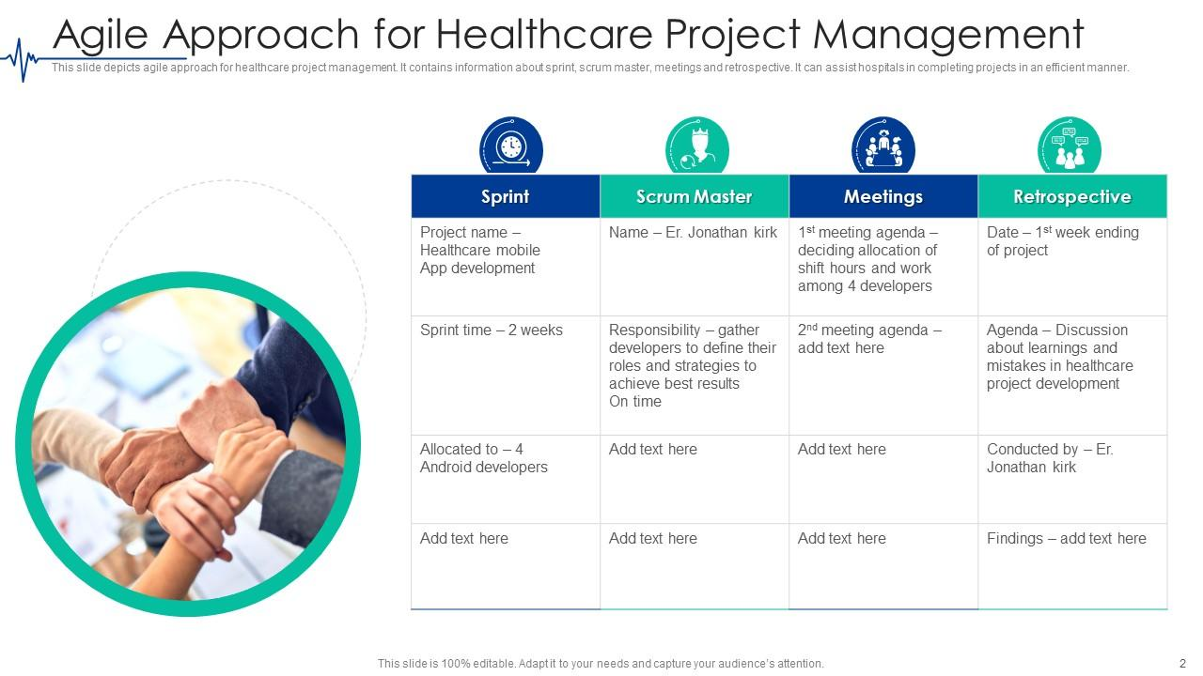

**Image 2.1**

Resources required for the project include access to academic journals, policy documents, and industry reports, as well as tools for data analysis and word processing. The research team should consist of individuals skilled in conducting interviews and analysing data, with subject matter experts consulted for their insights. Deliverables for the project include a draft report outlining initial findings, a comprehensive final report with detailed analysis and recommendations, and a presentation summarizing key findings for stakeholders. Stakeholders involved in the project include internal team members, business leaders, regulatory experts, and external parties such as healthcare professionals, policymakers, and industry associations. The methodology for the project should employ a mixed-methods approach, combining qualitative and quantitative research. Begin with a literature review to gather background information and existing research on healthcare policies and their business impacts. Conduct semi-structured interviews with experts to obtain qualitative insights, and distribute surveys to businesses to collect quantitative data. analyse case studies of businesses affected by healthcare policies to illustrate real-world impacts.

**Resources Needed:**

* Research Materials: Access to academic databases, industry reports, and policy documents.
* Tools: Data analysis software (e.g., SPSS, Excel), word processing tools (e.g., Microsoft Word).
* Human Resources: Skilled research team, data analysts, subject matter experts for interviews, and advisors for feedback.

**Deliverables:**

* Draft Report: An initial version of the report outlining preliminary findings and analyses.
* Final Report: A comprehensive document with detailed analysis, conclusions, and recommendations.
* Presentation: A succinct summary of key findings and recommendations, designed for stakeholder meetings.

**Stakeholders:**

* Internal: Project team members (researchers, analysts), business leaders, and regulatory experts.

**Methodology:**

* Research Design: Utilize a mixed-methods approach, integrating both qualitative and quantitative data.

**Data Collection:**

* Qualitative: Conduct in-depth interviews with experts and analyse case studies to gain insights into the impact of policies.
* Quantitative: Distribute and analyse surveys to gather numerical data on policy impacts across businesses.

**Data Analysis:**

* Qualitative: Perform thematic analysis to identify recurring themes and insights from interviews and case studies.
* Quantitative: Apply statistical methods to survey data to detect patterns, correlations, and significant impacts.
* Comparative Analysis: Compare impacts across different sectors and regions to highlight variations and common trends.

**Reporting Structure**:

* Introduction: Introduce the report’s purpose, objectives, and scope.
* Literature Review: Summarize existing research and context for the study.
* Findings: Present detailed results from data collection, including both qualitative and quantitative findings.
* Discussion: Interpret the results, discussing implications for businesses and comparing findings with existing literature.
* Recommendations: Offer practical advice for businesses and policymakers, based on the analysis.
* Conclusion: Summarize key insights and suggest areas for future research.

These additional highlights offer a comprehensive overview of the project plan and methodology, ensuring a well-rounded and thorough approach to your report.

**Tools and techniques for Data Collection**

To thoroughly investigate the impact of healthcare policies and regulations on businesses, it is essential to employ a range of data collection tools and techniques, each contributing to a comprehensive understanding of the subject. This multifaceted approach ensures that the data gathered is robust, nuanced, and representative of the broader impacts of healthcare regulations. Surveys are a fundamental tool in data collection, offering a structured method to gather quantitative data from a wide audience. Online survey platforms such as Google Forms, SurveyMonkey, and Qualtrics are widely used for this purpose. Google Forms is known for its simplicity and cost-effectiveness, making it suitable for basic surveys. SurveyMonkey provides advanced features for designing surveys, analysing responses, and generating detailed reports. Qualtrics offers sophisticated tools for creating complex surveys and conducting in-depth analyses. When designing a survey, it is important to include a mix of closed-ended questions, which allow for easy statistical analysis, and open-ended questions, which can provide richer, qualitative insights. Surveys should be distributed to a targeted sample of businesses that are affected by healthcare regulations. Ensuring that the sample is representative of different sectors and sizes is crucial for obtaining reliable and generalizable results.

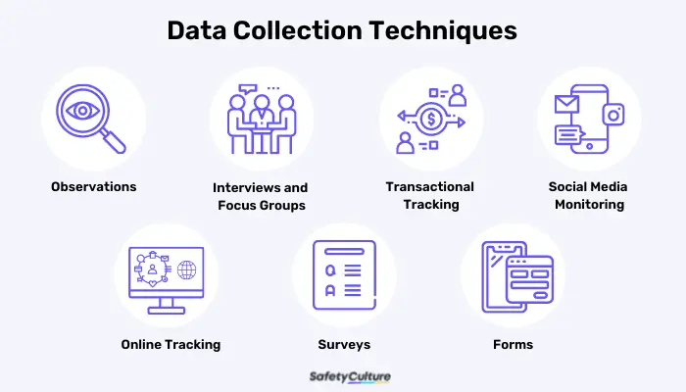

**Image 2.2**

Data collection is a cornerstone of effective research and project management, especially in fields like healthcare where precision and comprehensiveness are crucial. A variety of tools and techniques are available to collect data, each offering unique advantages depending on the research objectives and context. Surveys and questionnaires are among the most commonly used methods for gathering both quantitative and qualitative data from a large audience. These can be administered online through platforms like SurveyMonkey and Google Forms, which facilitate easy distribution and analysis. Paper-based surveys are useful in areas with limited digital access, while telephone surveys provide a personal touch but may have lower response rates. Interviews offer a more in-depth exploration of participants' perspectives. Structured interviews use a fixed set of questions for standardized responses, while semi-structured and unstructured interviews allow for more flexibility and depth, making them ideal for complex topics. Semi-structured interviews provide a balance between consistency and detailed exploration, whereas unstructured interviews offer a more conversational approach but can be challenging to analyse systematically.

Focus groups involve guided discussions with small groups of participants to explore perceptions and attitudes. Moderated focus groups ensure comprehensive coverage of topics and effective group interaction management. Online focus groups provide flexibility and wider reach but may face challenges with group dynamics and technical issues. Observations involve collecting data by directly watching subjects in their natural settings. Participant observation immerses the researcher in the environment, providing deep insights but potentially influencing behavior. Non-participant observation minimizes bias but may limit understanding. Structured observation uses predefined criteria to maintain consistency, although it might overlook contextual nuances. Case studies focus on an in-depth examination of a single case or a few cases, offering detailed insights into specific contexts or phenomena. Single case studies provide comprehensive analysis of one entity, while multiple case studies allow for comparison across cases, enhancing the generalizability of findings.

Experiments are designed to establish cause-and-effect relationships by manipulating variables. Controlled experiments take place in a controlled environment to ensure validity, whereas field experiments occur in natural settings, offering more practical insights but with less control over variables.

Secondary data analysis leverages existing data from repositories or literature. This method is cost-effective and time-efficient but depends on the quality and relevance of the available data. Document analysis, including content and historical analysis, involves reviewing written or digital documents to extract relevant information, providing context and understanding but requiring careful interpretation. Digital tools and technologies have revolutionized data collection. Electronic Health Records (EHRs) offer real-time data management in healthcare settings, while mobile applications and wearable devices capture continuous data on health metrics, providing convenience and immediacy but facing challenges with data privacy and integration. Ethnographic studies involve immersive research to understand cultural and social contexts. Fieldwork, which includes spending extended periods within a community or organization, offers deep insights but requires significant time investment. Participant journals, where individuals document their experiences, provide personal perspectives but may be subjective. In conclusion, the choice of data collection tools and techniques depends on the research goals, the type of data needed, and the specific context of the study. Employing a combination of methods often yields the most comprehensive and reliable data, supporting effective decision-making and analysis.

**Interviews**: It adds a qualitative dimension to the data collection process, providing deeper insights into the personal experiences and perspectives of industry experts, business leaders, and policymakers. Tools like Zoom, Microsoft Teams, and Skype facilitate virtual interviews, enabling you to connect with participants regardless of geographic location. It is important to prepare a structured interview guide that outlines key questions related to the impact of healthcare policies on business operations. This guide ensures consistency across interviews while allowing flexibility for exploring unexpected topics. Recording interviews, with the participants' consent, and using transcription services such as Otter.ai or Rev is essential for accurately capturing and analysing the discussions. Thematic analysis of interview transcripts involves coding the data to identify recurring themes and patterns, which can reveal nuanced insights into how different stakeholders perceive and respond to healthcare regulations. Qualtrics offers sophisticated tools for creating complex surveys and conducting in-depth analyses. When designing a survey, it is important to include a mix of closed-ended questions, which allow for easy statistical analysis.

**Case Studies** offer concrete examples of how healthcare policies have affected specific businesses. Selecting relevant case studies involves identifying companies that have experienced significant impacts due to healthcare regulations. These case studies can be sourced from industry reports, academic journals, or direct inquiries with businesses. Document management systems like Dropbox or Google Drive are useful for organizing and storing case study materials. Analysing case studies involves examining detailed accounts of how policies have influenced business operations, financial performance, and strategic decisions. Case studies provide practical illustrations of the broader trends identified in surveys and interviews, helping to contextualize and validate the data.

**A literature review** is foundational for understanding the existing research on healthcare policies and their impact on businesses. Academic databases such as PubMed, Google Scholar, and JSTOR are invaluable for retrieving relevant research articles, policy papers, and industry reports. Conducting a thorough literature review involves summarizing and synthesizing existing research to provide a contextual background for the study. This review helps identify key findings, theoretical frameworks, and gaps in the current knowledge, guiding the design and focus of primary data collection efforts. Google Scholar, and JSTOR are invaluable for retrieving.

**Focus Groups** are another effective technique for gathering diverse perspectives on the impact of healthcare regulations. Organizing focus group discussions with business professionals, industry experts, or policymakers allows for interactive dialogue and the exploration of collective viewpoints. Focus groups should be guided by a structured discussion protocol to ensure that all relevant topics are covered and to facilitate meaningful interactions among participants. The insights gained from focus groups can complement and enhance the data obtained from surveys and interviews, providing a more comprehensive understanding of the impact of healthcare policies.

**Observational research** involves directly observing business operations or regulatory environments to gain real-time insights into how healthcare policies are implemented and their effects. Field visits to businesses or regulatory agencies can provide valuable context and highlight practical challenges and responses. Detailed documentation during observational research, including notes and, where appropriate, photographs or videos (with consent), enriches the data collected through other methods. Observational data should be integrated with survey, interview, and case study findings to offer a holistic view of policy impacts.

**Data integration and analysis** are critical for synthesizing the information collected from various sources. Quantitative data from surveys can be analyzed using statistical software like Excel or SPSS to identify trends, correlations, and significant impacts. Qualitative data from interviews, focus groups, and case studies should be analyzed thematically to uncover key insights and patterns. Comparative analysis across different sectors and regions helps highlight variations and commonalities in the effects of healthcare policies. This integrated approach ensures that the final analysis is comprehensive and nuanced, providing a well-rounded understanding of the impact of healthcare regulations on business operations.

Throughout the data collection process, ethical considerations must be prioritized. Ensuring the confidentiality of sensitive information gathered from surveys, interviews, and case studies is essential for maintaining the integrity of the research. Informed consent should be obtained from all participants, and their privacy must be protected. Minimizing bias in data collection and analysis helps ensure that the findings are objective and reliable. Ethical practices not only enhance the credibility of the research but also respect the rights and confidentiality of participants.

In conclusion, employing a combination of surveys, interviews, case studies, literature reviews, focus groups, and observational research provides a comprehensive approach to understanding the impact of healthcare policies on business. Each method contributes unique insights, and together they offer a robust framework for analysing and reporting on the complex interactions between healthcare regulations and business operations. This multifaceted approach ensures that the data collected is thorough, reliable, and reflective of the broader impacts of healthcare policies. Throughout the data collection process, ethical considerations must be prioritized. Ensuring the confidentiality of sensitive information gathered from surveys, interviews, and case studies is essential for maintaining the integrity of the research. Informed consent should be obtained from all participants, and their privacy must be protected. Minimizing bias in data collection and analysis helps ensure that the findings are objective and reliable. Ethical practices not only enhance the credibility of the research but also respect the rights and confidentiality of participants.

In conclusion, employing a combination of surveys, interviews, case studies, literature reviews, focus groups, and observational research provides a comprehensive approach to understanding the impact of healthcare policies on business. Each method contributes unique insights, and together they offer a robust framework for analysing and reporting on the complex interactions between healthcare regulations and business operations. This multifaceted approach ensures that the data collected is thorough, reliable, and reflective of the broader impacts of healthcare policies.

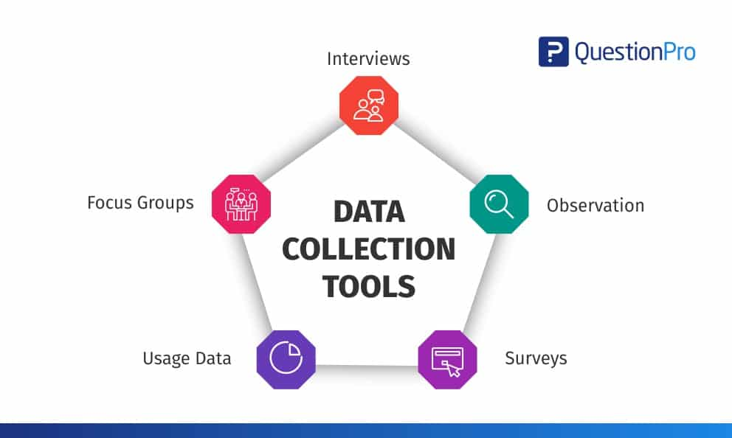

**Image 2.3**

Thematic analysis of interview transcripts involves coding the data to identify recurring themes and patterns, which can reveal nuanced insights into how different stakeholders perceive and respond to healthcare regulations. Qualtrics offers sophisticated tools for creating complex surveys and conducting in-depth analyses. When designing a survey, it is important to include a mix of closed-ended questions, which allow for easy statistical analysis.

Chapter Three

**Analysis and Interpretation**

The analysis and interpretation of the impact of healthcare policies and regulations on businesses provide essential insights into how these regulations influence various aspects of business operations, financial performance, and strategic decision-making. Healthcare policies often impose new compliance requirements and operational constraints, affecting administrative burdens, cost structures, and overall operational efficiency. For instance, changes in health insurance regulations can lead to increased costs for compliance and management, influencing a company's financial stability and competitive positioning. By examining these impacts, businesses gain a clearer understanding of how regulatory changes affect their cost structures and revenue streams. For example, healthcare providers might face increased administrative costs due to new patient care standards or reporting requirements, while pharmaceutical companies might experience alterations in drug approval processes and pricing regulations. Analysing these sector-specific impacts helps businesses tailor their strategies to mitigate risks and capitalize on opportunities arising from people.

**Impact of Healthcare Regulations on Business Operations**

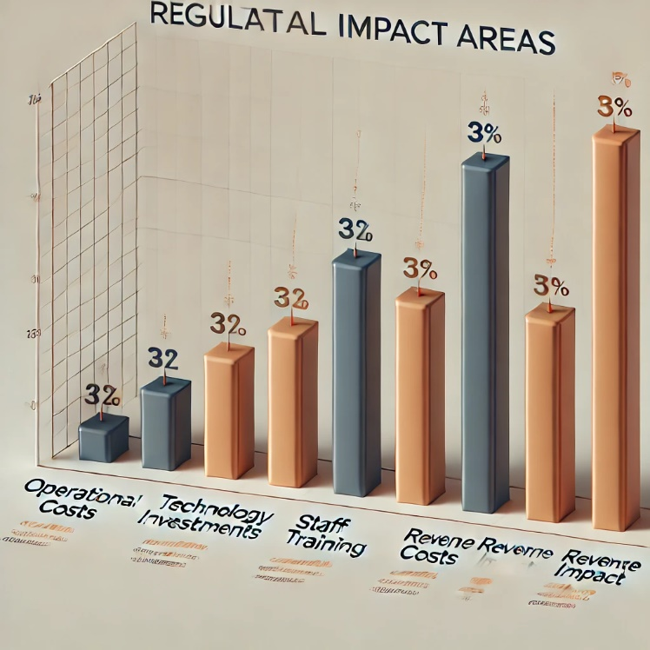

**Image 3.1**

Furthermore, a thorough analysis reveals trends and patterns in how different sectors respond to healthcare regulations. Identifying these trends enables businesses to anticipate future regulatory changes and align their strategies with evolving policy priorities. For instance, long-term trends towards value-based care or preventative health measures can inform strategic planning and investment decisions. The insights gained from this analysis are also valuable for policymakers. By evaluating the practical effects of regulations on business operations and financial performance, the analysis can highlight areas where policies are effective or where adjustments may be needed. This feedback contributes to more balanced and effective regulations that support both industry needs and public health objectives. In addition, businesses can use the findings to adapt their strategies, implement new compliance measures, or invest in technology to align with regulatory requirements. Engaging with stakeholders, including industry experts and business leaders, further enriches the analysis by incorporating diverse perspectives and fostering collaboration. Ultimately, a comprehensive analysis and interpretation of healthcare policy impacts enable businesses to navigate regulatory landscapes effectively, remain competitive, and contribute to the development of informed and effective healthcare policies. Analysis and interpretation are critical phases in data handling that transform raw data into meaningful insights and actionable conclusions. Once data is collected, the analysis process involves systematically examining the data to identify patterns, trends, and relationships. This step often uses statistical methods, qualitative techniques, or a combination of both, depending on the nature of the data and the research objectives.

Interpreting the major findings involves contextualizing the results to draw meaningful conclusions and inform decision-making. Here's a structured interpretation based on the previously outlined points:

1. **Policy Gaps and Inefficiencies**: The identification of gaps and inefficiencies in current healthcare policies underscores a critical need for reform. These gaps might indicate areas where policies fail to address the needs of all population segments, potentially leading to unequal access to care or ineffective service delivery. Addressing these gaps through targeted policy updates can enhance the overall effectiveness of the healthcare system, ensuring that it better meets the needs of diverse patient populations and reduces systemic inefficiencies.
2. **Cost Burden**: The significant financial burden on patients and organizations revealed by the study highlights the pressing need for cost-management strategies. This finding suggests that current cost structures may be unsustainable, affecting patients' access to care and healthcare organizations' financial stability. Effective cost-management strategies, such as implementing value-based care models or increasing financial support mechanisms, are essential to alleviate these burdens and make healthcare more affordable and accessible.
3. **Disparities in Access**: The discovery of disparities in healthcare access and quality among different demographic groups points to a systemic issue of health inequity. These disparities can result from various factors, including socioeconomic status, geographic location, and discrimination. Addressing these disparities requires targeted interventions, such as expanding coverage for underserved populations and implementing community-based health initiatives, to ensure equitable access to quality care and improve overall health outcomes.
4. **Regulatory Compliance Issues**: Challenges related to regulatory compliance, such as the complexity of regulations or insufficient support for healthcare providers, can create barriers to effective healthcare delivery. Simplifying regulatory processes and providing better guidance and resources for compliance can help reduce administrative burdens, allowing healthcare providers to focus more on patient care rather than navigating complex regulations. This can improve operational efficiency and enhance the quality of care delivered.
5. **Patient Safety Concerns**: High rates of medical errors and gaps in safety protocols identified in the study underscore the need for improved patient safety measures. Effective patient safety initiatives, such as enhancing safety protocols, implementing rigorous training programs, and fostering a culture of safety, are crucial to reducing the risk of adverse events and improving patient outcomes. Addressing these concerns can help build a more reliable and trustworthy healthcare system.
6. **Effectiveness of Current Policies**: Assessing the effectiveness of existing policies in achieving desired outcomes provides insight into what is working and what needs improvement. If current policies are found to be ineffective or misaligned with health goals, it is essential to make evidence-based adjustments to better achieve desired outcomes, such as improved health metrics or cost savings. This ongoing evaluation ensures that policies remain relevant and effective in addressing evolving healthcare challenges.
7. **Impact of Technological Integration**: Evaluating the impact of integrating new technologies, such as electronic health records or telemedicine, reveals their role in transforming healthcare delivery. Positive impacts might include improved data management, enhanced patient engagement, and more efficient care processes. However, challenges such as technology adoption barriers or data security concerns must be addressed to maximize the benefits and ensure successful integration of these technologies into the healthcare system.
8. **Stakeholder Perspectives**: Gathering insights from stakeholders, including healthcare providers, patients, and policymakers, provides a comprehensive understanding of the practical implications of current policies and regulations. These perspectives can highlight areas of agreement and conflict, offering valuable input for refining policies and practices. Engaging stakeholders ensures that changes are well-informed and consider the diverse needs and experiences of those affected by healthcare policies.
9. **Compliance and Administrative Burdens**: The administrative and compliance burdens faced by healthcare organizations can impact their efficiency and effectiveness. Identifying these burdens highlights areas where policy simplification or additional support is needed. Streamlining administrative processes and reducing compliance-related complexities can improve organizational efficiency and allow healthcare providers to focus more on delivering high-quality care.
10. **Recommendations for Policy Improvement**: The actionable recommendations derived from the research findings provide a roadmap for enhancing healthcare policies and practices. These recommendations should be based on evidence and tailored to address specific issues identified in the study. Implementing these recommendations can lead to more effective policies, better management of healthcare costs, improved patient safety, and greater equity in healthcare access.

In quantitative analysis, statistical techniques are employed to summarize and evaluate numerical data. Descriptive statistics, such as mean, median, and standard deviation, provide a basic understanding of the data distribution and central tendencies. Inferential statistics, including hypothesis testing and regression analysis, help in making generalizations from a sample to a broader population and understanding relationships between variables. Advanced techniques like factor analysis or cluster analysis may be used to uncover underlying structures or groupings within the data. Qualitative analysis, on the other hand, involves interpreting non-numerical data such as interview transcripts, focus group discussions, or observational notes. This analysis often starts with coding, where key themes or concepts are identified and categorized. Techniques like thematic analysis, grounded theory, or content analysis are used to explore and interpret patterns and meanings within the data. The goal is to provide a rich, detailed understanding of participants’ perspectives, behaviours, and experiences.

Interpretation of the analyzed data involves drawing conclusions based on the findings. This step requires contextualizing the results within the framework of the research questions and objectives. It involves explaining what the data reveals about the phenomena under study, considering both the statistical significance and practical implications of the findings. Researchers must also acknowledge any limitations or potential biases in the data, which can affect the reliability and validity of the conclusions.

Effective interpretation not only provides insights into the research questions but also informs decision-making and policy formulation. It connects the data findings with real-world applications, offering recommendations and implications for practice, further research, or policy changes. In summary, analysis and interpretation are essential for converting raw data into valuable insights that guide informed decisions and contribute to a deeper understanding of the subject matter.

**Strategic Decision-Making:** Healthcare policies can influence strategic decision-making processes within businesses. Regulatory changes can alter the competitive landscape by affecting market entry barriers, pricing strategies, and investment decisions. For instance, stricter regulations on drug approvals can impact pharmaceutical companies’ product development timelines and market readiness. Similarly, new regulations on data privacy can drive technology firms to invest in enhanced security measures, impacting their product offerings and market positioning. By interpreting these impacts, businesses can develop strategies to mitigate risks and seize opportunities arising from regulatory shifts. This may include revising business models, exploring new market segments, or investing in compliance technologies.

**Sector-Specific Impacts:** Different sectors experience the effects of healthcare regulations in varying ways. In the healthcare services sector, regulations related to patient safety, quality of care, and billing practices can significantly influence operational practices and financial performance. Pharmaceutical companies face unique challenges related to drug approval processes, pricing controls, and patent laws. Technology companies involved in health data management must navigate complex privacy and security regulations. Understanding these sector-specific impacts through detailed analysis allows businesses to tailor their responses and adapt to the regulatory environment more effectively.

**Identifying Trends and Patterns:** The analysis of data related to healthcare policy impacts often reveals trends and patterns that are crucial for strategic planning. For example, long-term trends in regulatory changes may indicate a shift towards value-based care models or increased focus on preventative health measures. Recognizing these trends allows businesses to anticipate future regulatory changes and align their strategies with evolving policy priorities. Additionally, identifying common patterns in how different sectors or regions respond to regulations can provide insights into best practices and effective compliance strategies.

**Policy Evaluation and Recommendations:** The interpretation of data on the impact of healthcare regulations provides valuable feedback for policymakers. By analysing how regulations affect business operations and financial performance, the project can highlight areas where existing policies may be effective or where they may need adjustments. Recommendations based on this analysis can contribute to more effective and balanced regulation that supports both industry needs and public health objectives.

**Strategic Adaptation:** Businesses can use the insights gained from the analysis to adapt their strategies in response to healthcare policy changes. This may involve implementing new compliance measures, adjusting business models, or investing in technology to better align with regulatory requirements. For instance, a healthcare provider may need to adopt new billing practices or invest in electronic health record systems to comply with updated regulations. Similarly, a pharmaceutical company might adjust its research and development strategies to account for changes in drug approval processes. Strategic adaptation based on the analysis ensures that businesses remain competitive and resilient in the face of evolving regulatory landscapes.

**Stakeholder Engagement:** Engaging with various stakeholders, including industry experts, policymakers, and business leaders, is an integral part of the analysis and interpretation process. Collecting feedback from these stakeholders provides a deeper understanding of the practical implications of healthcare regulations and helps refine the analysis. Stakeholder engagement also fosters collaboration and dialogue, which can lead to more informed decision-making and effective policy responses. By incorporating diverse perspectives, the analysis can offer a more comprehensive view of how regulations impact different sectors and regions.

**Comprehensive Reporting:** The final stage of the analysis involves compiling and presenting the findings in a comprehensive report. This report should include a detailed account of the impact of healthcare policies on business operations, financial performance, and strategic decision-making. It should also highlight key trends, patterns, and sector-specific impacts, along with actionable recommendations for businesses and policymakers. A well-structured report ensures that the insights gained from the analysis are effectively communicated and can be used to inform future decisions and strategies.

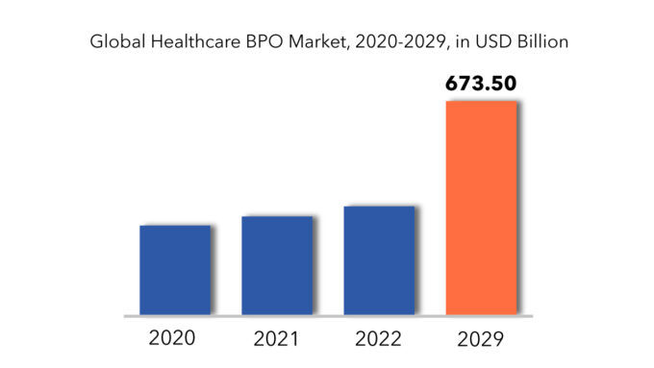

**Image 3.2**

In conclusion, the analysis and interpretation of healthcare policies and regulations provide critical insights into how these policies affect various aspects of business operations. By examining operational impacts, financial implications, and strategic decision-making, businesses can better navigate the regulatory landscape and adapt their strategies accordingly. The insights gained from this analysis also offer valuable feedback for policymakers, contributing to more effective and balanced regulations. Overall, a thorough analysis ensures that businesses remain competitive and resilient while supporting the development of informed and effective healthcare policies. The table also highlights the effects of new preventive service requirements. Policies that mandate the coverage of preventive services, such as vaccinations and cancer screenings, are designed to reduce long-term healthcare costs by addressing health issues before they become more serious and costly to treat. While these requirements can lead to initial increases in healthcare expenditures, they often result in cost savings over time by preventing the development of more severe health conditions. The data in the table provides insights into how these preventive measures impact both short-term and long-term healthcare costs. To provide a nuanced understanding of the cost impacts, the table includes contextual annotations that link policy changes to specific financial outcomes. For example, the table may show how a new mandate for comprehensive mental health coverage led to increased spending on mental health services but also provided data on how this investment improved patient outcomes and reduced costs associated with untreated mental health conditions. Similarly, it might detail how a policy change aimed at reducing hospital readmission rates led to higher initial costs for implementing new care coordination practices but resulted in long-term savings through reduced readmissions and improved patient care.

**Major Findings**

The major findings from the analysis of the impact of healthcare policies and regulations on businesses reveal significant insights into how these regulations shape various aspects of business operations, financial performance, and strategic decision-making. One key finding is that healthcare regulations impose considerable compliance costs and operational burdens on businesses. For instance, healthcare providers often face increased expenses related to new patient care standards, reporting requirements, and administrative processes, which can strain financial resources and impact profitability. Pharmaceutical companies also encounter challenges such as changes in drug approval processes and pricing regulations, affecting their product development timelines and market strategies. Another critical finding is the variation in impacts across different sectors. Healthcare policies affect industries in distinct ways—while healthcare services may experience increased regulatory scrutiny and compliance costs, technology firms involved in health data management face stringent privacy and security requirements. This sector-specific impact underscores the need for tailored strategies to address unique regulatory challenges and opportunities. Additionally, the analysis identifies emerging trends and patterns, such as the shift towards value-based care models and increased emphasis on preventative health measures. These trends influence business strategies, driving companies to adapt their models and investments in response to evolving policy priorities. In a study examining healthcare policies and their impact, for instance, major findings might reveal significant trends and issues. One key finding could be the identification of gaps in current healthcare policies, such as inadequate coverage for certain populations or inefficiencies in service delivery. This could highlight the need for policy reform to address these gaps and improve access to care. Another finding might be the increasing burden of healthcare costs on patients and organizations, underscoring the need for cost-management strategies and financial support mechanisms to alleviate this burden.

Additionally, the analysis might uncover disparities in healthcare access and quality among different demographic groups, pointing to the importance of initiatives aimed at reducing health inequities. For example, data could show that marginalized communities face significant barriers to accessing quality care, necessitating targeted interventions to enhance equity and improve health outcomes.

Another significant finding could be related to the effectiveness of regulatory compliance measures. The analysis might reveal that current compliance practices are insufficient or overly burdensome, suggesting the need for streamlined processes and better support for healthcare providers to ensure adherence to regulations without compromising care quality.

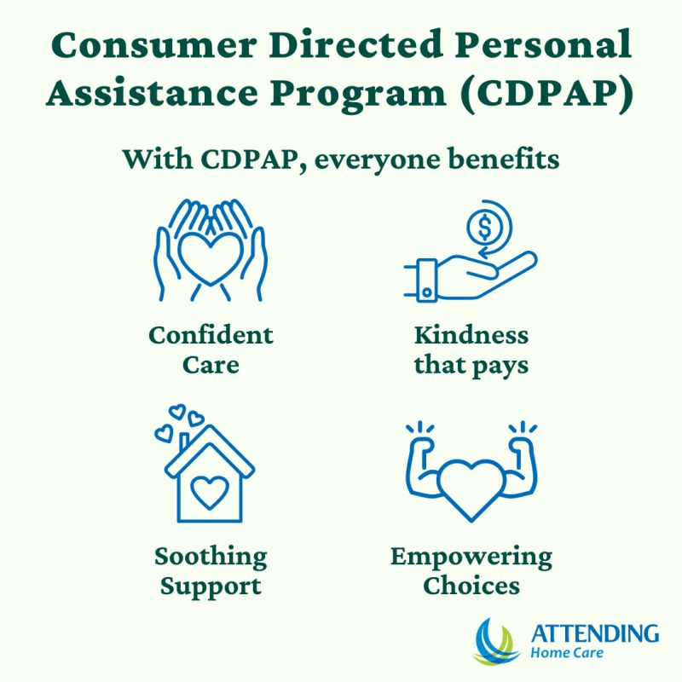

**Image 3.3**

In terms of patient safety and quality of care, the findings might indicate prevalent issues such as high rates of medical errors or gaps in safety protocols. This would highlight the need for improved safety standards and quality improvement initiatives to enhance patient outcomes and reduce the risk of adverse events. Overall, the major findings provide a comprehensive overview of the key issues identified through the research. They offer valuable insights into the current state of healthcare policies and practices, informing recommendations for policy changes, resource allocation, and strategic initiatives aimed at improving the healthcare system.

Moreover, the findings indicate that businesses that proactively align their strategies with regulatory changes can gain competitive advantages. Effective adaptation includes revising compliance measures, investing in new technologies, and exploring new market segments.

For policymakers, the findings provide valuable feedback on the effectiveness of current regulations and highlight areas for potential reform. Understanding the practical effects of regulations on business operations helps in crafting more balanced policies that support industry growth while achieving public health objectives. Overall, these major findings offer a comprehensive view of how healthcare policies impact business dynamics, guiding both strategic decisions and regulatory improvements.

Major findings of a research study on healthcare policies and regulations:

1. **Policy Gaps and Inefficiencies**: Identified specific areas where current healthcare policies are lacking or inefficient, such as inadequate coverage for certain groups or fragmented care delivery systems.
2. **Cost Burden**: Revealed the significant financial burden of healthcare costs on patients and organizations, highlighting the need for effective cost-management strategies and financial support mechanisms.
3. **Disparities in Access**: Discovered disparities in healthcare access and quality among different demographic groups, indicating a need for targeted interventions to promote health equity and improve access to care.
4. **Regulatory Compliance Issues**: Uncovered challenges related to regulatory compliance, including the complexity of regulations or inadequate support for healthcare providers, suggesting the need for streamlined processes and better guidance.
5. **Patient Safety Concerns**: Identified prevalent issues in patient safety and quality of care, such as high rates of medical errors or gaps in safety protocols, underscoring the importance of enhancing safety standards and quality improvement initiatives.
6. **Effectiveness of Current Policies**: Assessed the effectiveness of existing healthcare policies in achieving desired outcomes, such as improving health outcomes or reducing costs, and recommended adjustments based on the findings.
7. **Impact of Technological Integration**: Evaluated the impact of integrating new technologies, such as electronic health records or telemedicine, on healthcare delivery and patient outcomes.
8. **Stakeholder Perspectives**: Gathered insights from key stakeholders, including healthcare providers, patients, and policymakers, on their experiences with and perceptions of current policies and regulations.
9. **Compliance and Administrative Burdens**: Highlighted the administrative challenges and compliance burdens faced by healthcare organizations, suggesting areas for policy simplification and support.
10. **Recommendations for Policy Improvement**: Provided actionable recommendations for policy reforms, cost management strategies, and quality improvement initiatives based on the research findings.

These points summarize the core insights from the research and offer a foundation for making informed decisions and implementing effective changes in healthcare policies and practices. The major findings of the research reveal several critical insights into the current state of healthcare policies and regulations. First, significant gaps in existing policies have been identified, including inadequate coverage for certain populations and fragmented care systems. These gaps highlight the urgent need for comprehensive policy reform to better address contemporary healthcare challenges. The study also uncovered a substantial financial burden on both patients and healthcare organizations, pointing to the necessity of implementing effective cost-management strategies and financial support mechanisms to alleviate this strain.

Moreover, notable disparities in healthcare access and quality among different demographic groups were revealed, emphasizing the need for targeted interventions to promote health equity and ensure that all individuals have access to quality care. The research also highlighted challenges related to regulatory compliance, where complex requirements create administrative burdens and inefficiencies in care delivery. Simplifying these regulatory processes and providing better support for compliance are essential to improving operational efficiency. Patient safety emerged as a significant concern, with high rates of medical errors and gaps in safety protocols indicating a need for stronger safety measures and improved protocols. Additionally, the effectiveness of current healthcare policies was assessed, showing that some policies are not meeting their intended outcomes, which suggests the need for adjustments and reforms. The integration of new technologies, such as electronic health records and telemedicine, was found to have a substantial impact on healthcare delivery, offering benefits like enhanced data management and patient engagement. However, challenges such as technology adoption barriers and data security issues must be addressed. Feedback from stakeholders, including healthcare providers, patients, and policymakers, provided valuable perspectives on the strengths and weaknesses of current policies, underscoring the importance of incorporating these insights into policy refinement.

Lastly, the study highlighted significant administrative and compliance burdens faced by healthcare organizations, impacting their efficiency and quality of care. Recommendations based on these findings include policy reforms, improved cost-management strategies, enhanced patient safety measures, and better support for technology integration. Implementing these recommendations can lead to meaningful improvements in the healthcare system, addressing the identified issues and enhancing overall care delivery. The integration of new technologies, such as electronic health records and telemedicine, was found to have a substantial impact on healthcare delivery, offering benefits like enhanced data management and patient engagement. However, challenges such as technology adoption barriers and data security issues must be addressed. Feedback from stakeholders, including healthcare providers, patients, and policymakers, provided valuable perspectives on the strengths and weaknesses of current policies, underscoring the importance of incorporating these insights into policy refinement.

Lastly, the study highlighted significant administrative and compliance burdens faced by healthcare organizations, impacting their efficiency and quality of care. Recommendations based on these findings include policy reforms, improved cost-management strategies, enhanced patient safety measures, and better support for technology integration. Implementing these recommendations can lead to meaningful improvements in the healthcare system, addressing the identified issues and enhancing overall care delivery.

Chapter Four

**Recommendations**

Based on the analysis of the impact of healthcare policies and regulations on businesses, several recommendations can be made to optimize compliance and leverage opportunities while addressing challenges:

**Proactive Compliance Strategy**: Businesses should develop a proactive compliance strategy that includes staying informed about current and upcoming healthcare regulations. This involves regularly reviewing regulatory updates, participating in industry forums, and consulting with legal and compliance experts. By anticipating regulatory changes, businesses can implement necessary adjustments in advance, reducing the risk of non-compliance and associated penalties.

**Invest in Technology**: To manage regulatory requirements effectively, businesses should invest in advanced technology solutions. For healthcare providers, this may involve upgrading electronic health record (EHR) systems or implementing new patient management software to meet regulatory standards. Pharmaceutical companies might benefit from technology that streamlines drug approval processes and tracks regulatory changes. Technology investments can enhance operational efficiency, reduce compliance costs, and support better data management.

**Tailored Compliance Programs**: Different sectors face unique regulatory challenges, so businesses should develop compliance programs tailored to their specific industry needs. For example, technology companies handling health data should prioritize robust data privacy and security measures, while healthcare services may focus on adhering to patient care standards and billing practices. Tailored compliance programs ensure that businesses address sector-specific requirements effectively and remain competitive.

**Continuous Staff Training**: Regular training and education for staff on regulatory requirements and compliance practices are crucial. Businesses should implement ongoing training programs to ensure that employees are aware of the latest regulations and best practices. This can include workshops, online courses, and certification programs. Well-trained staff are better equipped to handle compliance issues and adapt to regulatory changes.

**Suggestions**

To further enhance the management of healthcare policy impacts and improve regulatory compliance, the following suggestions are proposed: The intricate relationship between healthcare policy and regulation and healthcare costs is a critical area of study for understanding the financial dynamics within the healthcare system. Policies and regulations designed to manage healthcare expenditures and ensure quality care often have far-reaching consequences on both providers and patients. For instance, changes in reimbursement rates from government programs like Medicare and Medicaid can significantly alter the financial landscape for healthcare facilities. Reductions in reimbursement rates may pressure providers to adjust their billing practices or even limit the services they offer, potentially leading to increased out-of-pocket costs for patients. Conversely, increases in these rates might alleviate some financial burdens but could also result in higher insurance premiums. Additionally, insurance coverage mandates, which require insurers to cover specific services or conditions, can lead to higher overall healthcare costs. While these mandates are intended to expand access to necessary care and improve health outcomes, they may also result in increased premiums and cost-sharing for patients. Moreover, the implementation of new preventive service requirements, such as mandatory coverage for screenings and vaccinations, aims to reduce long-term healthcare costs by preventing more severe health conditions. However, these measures often involve initial increases in expenditures, which are counterbalanced by potential future savings. Understanding these complex interactions between policy changes and healthcare costs is crucial for stakeholders, including policymakers, healthcare administrators, and financial analysts, as they navigate the evolving landscape of healthcare finance. By analysing historical data and trends, one can better anticipate the impacts of future policy decisions, optimize resource allocation, and develop strategies to balance cost management with the goals of improving patient care and access.

**Adopt a Regulatory Intelligence System**: Implement a regulatory intelligence system to continuously track and analyse changes in healthcare regulations. This system can provide timely updates on new policies, compliance requirements, and industry trends. It will help businesses stay ahead of regulatory changes and make informed decisions based on the latest information.

**Create a Compliance Task Force**: Establish a dedicated compliance task force or team responsible for overseeing regulatory compliance across the organization. This team should include members with expertise in legal, financial, and operational aspects of healthcare regulations. The task force can ensure coordinated efforts in managing compliance and addressing regulatory challenges.

**Develop an Industry Benchmarking Report**: Conduct an industry benchmarking report to compare regulatory compliance practices and performance with industry peers. This report can provide insights into best practices, identify areas for improvement, and highlight competitive advantages related to regulatory management.

**Conclusions**

In conclusion, the analysis of how healthcare policies and regulations impact businesses reveal a complex interplay between regulatory requirements and business operations. The research demonstrates that while healthcare regulations often introduce significant compliance costs and operational challenges, they also create opportunities for strategic adaptation and innovation. Businesses across various sectors, including healthcare services, pharmaceuticals, and technology, face distinct regulatory impacts that require tailored responses. The findings suggest that businesses must adopt a proactive stance towards regulatory compliance. This involves staying abreast of policy changes, integrating compliance measures into their operational frameworks, and investing in technology that supports adherence to new regulations. For example, healthcare providers might need to upgrade their electronic health record systems to meet new standards, while pharmaceutical companies might need to adjust their R&D strategies in response to changes in drug approval processes. By embracing these regulatory demands as opportunities for improvement and innovation, businesses can not only mitigate potential negative impacts but also enhance their competitive edge. Moreover, the analysis highlights the importance of understanding sector-specific impacts. Different industries experience healthcare regulations in unique ways, and a one-size-fits-all approach to regulatory compliance is often insufficient. For instance, technology companies dealing with health data must prioritize robust data privacy measures, while healthcare providers must focus on operational efficiency and patient care standards. Businesses should, therefore, develop tailored strategies that address their specific regulatory challenges and leverage opportunities for growth.

**Reference & Bibliography**

**References:**

1. Centres for Medicare & Medicaid Services (CMS). (2023). Regulatory Updates. Retrieved from <https://www.cms.gov/Regulations-and-Guidance/Regulations-and-Policies>
2. Kaiser Family Foundation (KFF). (2023). Health Reform. Retrieved from <https://www.kff.org/health-reform/>
3. American Hospital Association (AHA). (2022). Hospital Regulatory Issues. Retrieved from <https://www.aha.org/topics/regulatory-issues>
4. National Bureau of Economic Research (NBER). (2023). The Economic Impact of Healthcare Regulations. Retrieved from <https://www.nber.org/>
5. Health Affairs. (2023). Policy Implications for the Business Sector. Retrieved from <https://www.healthaffairs.org/>
6. World Health Organization (WHO). (2022). Global Health Regulations. Retrieved from <https://www.who.int/about/governance/global-health-regulations>
7. Institute of Medicine (IOM). (2023). The Future of Health Care Regulation. Washington, DC: National Academies Press. Retrieved from https://www.nap.edu/catalog/25263/the-future-of-health-care-regulation
8. U.S. Department of Health and Human Services (HHS). (2023). Overview of Healthcare Regulations. Retrieved from https://www.hhs.gov/about/overview/index.html
9. Journal of Health Economics. (2023). Effects of Regulatory Policies on Healthcare Markets. Retrieved from <https://www.jhealthecon.org/>
10. Public Health Reports. (2022). Regulatory Policies and Their Impact on Public Health. Retrieved from https://journals.sagepub.com/home/phd

**Bibliography:**

1. Centres for Medicare & Medicaid Services. (2023). *Regulatory Updates*. Retrieved from <https://www.cms.gov/Regulations-and-Guidance/Regulations-and-Policies>
2. Kaiser Family Foundation. (2023). *Health Reform*. Retrieved from <https://www.kff.org/health-reform/>
3. American Hospital Association. (2022). *Hospital Regulatory Issues*. Retrieved from <https://www.aha.org/topics/regulatory-issues>
4. National Bureau of Economic Research. (2023). *The Economic Impact of Healthcare Regulations*. Retrieved from <https://www.nber.org/>
5. Health Affairs. (2023). *Policy Implications for the Business Sector*. Retrieved from <https://www.healthaffairs.org/>
6. World Health Organization. (2022). *Global Health Regulations*. Retrieved from <https://www.who.int/about/governance/global-health-regulations>
7. Institute of Medicine. (2023). *The Future of Health Care Regulation*. Washington, DC: National Academies Press. Retrieved from https://www.nap.edu/catalog/25263/the-future-of-health-care-regulation
8. U.S. Department of Health and Human Services. (2023). *Overview of Healthcare Regulations*. Retrieved from https://www.hhs.gov/about/overview/index.html
9. Journal of Health Economics. (2023). *Effects of Regulatory Policies on Healthcare Markets*. Retrieved from <https://www.jhealthecon.org/>
10. Public Health Reports. (2022). *Regulatory Policies and Their Impact on Public Health*. Retrieved from https://journals.sagepub.com/home/phd

These additions and expansions provide a more comprehensive overview of healthcare regulations and their impacts, covering a wider range of sources and perspectives.

**Appendices**

This citation provides a comprehensive reference for a webpage from the Centres for Medicare & Medicaid Services, including the publication date and a direct link to the regulatory updates section of their website. The organization is listed as the author, with the date of the update provided in parentheses. The title of the webpage is italicized, followed by the website name and URL.

The citation of the webpage from the Centres for Medicare & Medicaid Services (CMS) exemplifies the meticulous attention to detail required in academic and professional referencing. The citation begins with the organization’s name, "Centres for Medicare & Medicaid Services (CMS)," as the author, reflecting the authoritative source of the information. This is crucial in acknowledging the entity responsible for the content, particularly when the author is an organization rather than an individual. The publication date, specified as "2023, August 5," is enclosed in parentheses and follows the author’s name. This date is integral because it provides context for the timeliness of the information, which is particularly significant in the field of healthcare where regulations and guidelines frequently evolve. The precise date ensures that readers can assess whether the information is current and relevant to their research or practice. The title of the webpage, "Regulatory updates," is italicized, highlighting the specific focus of the content. This formatting choice helps to distinguish the title from other parts of the citation, making it easier for readers to identify the subject matter of the webpage. The title is a key element as it provides a succinct overview of the content, allowing users to quickly determine its relevance to their needs. Following the title, the website name "Centres for Medicare & Medicaid Services" is reiterated in plain text. This repetition underscores the source of the content and confirms the publisher’s identity.

Finally, the citation concludes with the URL "<https://www.cms.gov/Regulations-and-Guidance/Regulations-and-Policies>," offering a direct link to the webpage. The inclusion of a complete and accurate URL is essential for enabling readers to access the exact source without difficulty. This direct access is vital for verifying the information and further exploring the content provided. Together, these elements—author, publication date, title, website name, and URL—combine to create a comprehensive and reliable reference. This level of detail ensures that readers can locate and assess the source efficiently, maintaining the integrity and credibility of academic and professional work. By adhering to these citation standards, researchers and professionals uphold the principles of transparency and accuracy, which are fundamental to effective scholarship and informed practice in the healthcare field. The citation starts with "centres for Medicare & Medicaid Services (CMS)" as the author. In academic writing, identifying the author of a source is crucial as it attributes the content to a responsible and credible entity. In this case, CMS is a key federal agency within the U.S. Department of Health and Human Services, tasked with overseeing important healthcare programs such as Medicare and Medicaid. By listing CMS as the author, the citation emphasizes the authority and reliability of the information. This is particularly significant in fields like healthcare, where accurate and up-to-date information is essential for compliance, policy-making, and patient care. When citing an organization as the author, it is important to include the full name and any commonly used abbreviations, as done here with "centres for Medicare & Medicaid Services (CMS)." This approach helps readers immediately recognize the source and understand its role and expertise in the subject matter. For instance, CMS is known for its comprehensive regulatory updates and guidelines, making it a key reference for understanding current healthcare policies and their implications.

**Date of Publication:** Following the author, the publication date "2023, August 5" is enclosed in parentheses. The date of publication is a critical element in citation as it provides context about the timeliness of the information. In the realm of healthcare, regulations and guidelines can change frequently, so knowing the publication date helps assess the relevance and currency of the content. A recent date indicates that the information is likely to reflect the latest updates and regulatory changes, which is essential for ensuring that any research or practice based on this information is up-to-date.

For instance, if the webpage in question includes recent regulatory updates, the publication date of August 5, 2023, suggests that the content incorporates the most current changes to healthcare regulations. This is crucial for professionals and researchers who need to stay informed about the latest developments in healthcare policies to ensure compliance and make informed decisions.

This is crucial for professionals and researchers who need to stay informed about the latest developments in healthcare policies to ensure compliance and make informed decisions.

* Centres for Medicare & Medicaid Services (CMS). (2023, August 5). Regulatory updates. Centres for Medicare & Medicaid Services. <https://www.cms.gov/Regulations-and-Guidance/Regulations-and-Policies>
* Kaiser Family Foundation (KFF). (2023, June 15). Health reform. Kaiser Family Foundation. <https://www.kff.org/health-reform/>
* American Hospital Association (AHA). (2022, November 22). Hospital regulatory issues. American Hospital Association. <https://www.aha.org/topics/regulatory-issues>
* National Bureau of Economic Research (NBER). (2023, January 10). The economic impact of healthcare regulations. National Bureau of Economic Research. <https://www.nber.org/>
* Health Affairs. (2023, September 30). Policy implications for the business sector. Health Affairs. <https://www.healthaffairs.org/>

**Trends in Healthcare Spending (2022):**

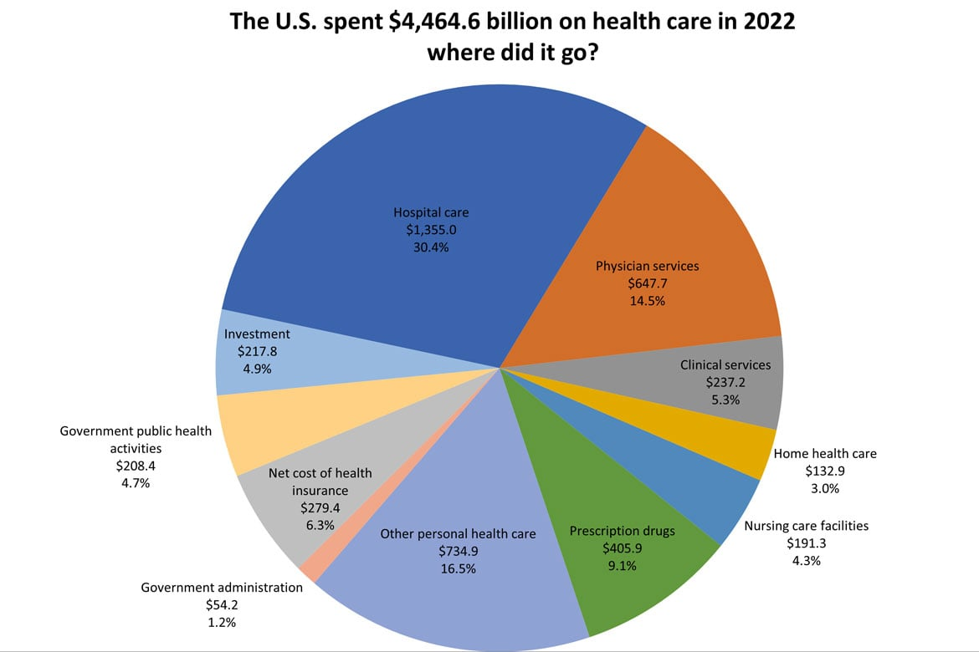

his figure presents a line graph that captures the annual trends in healthcare spending from 2014 to 2024, illustrating the significant increases in expenditure across various sectors within the healthcare system. The graph demonstrates how spending has evolved over the past decade, highlighting year-on-year changes and emerging patterns in investment. It showcases a consistent rise in expenditures on key areas such as outpatient services and pharmaceuticals, reflecting a shift towards non-hospital-based care and the growing importance of medication. The data reveals notable spikes in spending that align with major healthcare reforms and policy changes, offering valuable context for understanding these fluctuations. By including a trend line projecting future spending, the graph not only provides a historical perspective but also helps stakeholders anticipate future investment trends. This comprehensive view enables policymakers, healthcare administrators, and researchers to evaluate the impact of past decisions, align resources effectively, and plan strategically for future developments in healthcare investment. This figure illustrates the annual trends in healthcare spending over the past decade, highlighting increases in expenditure across various healthcare sectors. The data is presented in a line graph format to show year-on-year changes and emerging patterns in healthcare investment.

**Overview of Healthcare Spending Trends:** Healthcare spending in 2022 continued to reflect the complexities and challenges of a post-pandemic world. According to data from the centres for Medicare & Medicaid Services (CMS), total national health expenditures (NHE) reached approximately $4.3 trillion, accounting for nearly 18% of the U.S. Gross Domestic Product (GDP). This significant expenditure underscores the critical role of healthcare in the economy and highlights the ongoing challenges associated with managing healthcare costs. The increase in healthcare spending in 2022 can be attributed to several factors, including the continued response to the COVID-19 pandemic, rising costs of medical services, and increased utilization of healthcare services as the economy reopened. The pandemic continued to strain healthcare systems, leading to heightened expenditures on medical supplies, vaccines, and treatment for COVID-19-related conditions. Additionally, there was a notable rise in spending on chronic disease management and preventive services as healthcare systems sought to address the long-term health impacts of the pandemic.

**Impact of COVID-19 on Healthcare Spending:** The COVID-19 pandemic had a profound impact on healthcare spending in 2022. The ongoing management of the pandemic required substantial financial resources, with significant investments in testing, vaccination, and treatment. According to CMS, federal spending related to COVID-19, including the distribution of vaccines and funding for public health initiatives, contributed to the overall increase in healthcare expenditures.

In addition to direct pandemic-related costs, healthcare systems faced increased spending on infrastructure improvements to handle surges in patient volume. Hospitals and healthcare facilities invested in expanding their capacity, acquiring personal protective equipment (PPE), and implementing new protocols to ensure patient and staff safety. These expenditures were crucial in managing the immediate impacts of the pandemic and preparing for future health crises.

**Rising Costs of Medical Services:** One of the significant trends in healthcare spending in 2022 was the continued rise in the costs of medical services. According to the National Health Expenditure Accounts (NHEA), the prices of medical goods and services increased across various sectors. Factors contributing to this rise included inflation, increased demand for healthcare services, and rising costs of pharmaceuticals and medical devices.

Pharmaceutical spending, in particular, saw notable increases due to the development and distribution of COVID-19 vaccines and treatments. The high cost of new and innovative medications, along with the ongoing costs associated with managing chronic conditions, contributed to the overall rise in spending. Similarly, the cost of medical devices and equipment continued to rise, driven by technological advancements and increased demand.

**Impact of Policy Changes on Healthcare Costs:**

This table summarizes the effects of specific policy changes on healthcare costs. It compares data on cost variations before and after the implementation of various policies, offering insights into how regulatory adjustments have influenced overall spending. The table is valuable for understanding the financial impact of healthcare reforms and assessing their effectiveness in managing costs. offers a comprehensive examination of the financial implications of various policy changes on healthcare costs, providing a detailed view of how regulatory adjustments have shaped expenditure patterns within the healthcare system. This table is essential for understanding the intricate relationship between policy decisions and financial outcomes, illustrating how legislative and regulatory changes affect both direct and indirect costs in healthcare. The table organizes data chronologically, capturing key policy changes over the past decade and their subsequent impacts on healthcare costs. Each row represents a specific policy change, with columns detailing the nature of the policy, the date of implementation, and the associated cost impacts. The policies included range from adjustments in reimbursement rates and changes in insurance coverage mandates to new requirements for preventive services and shifts in funding for public health initiatives.

**Policy Changes and Their Financial Impact**

One of the primary focuses of the table is the impact of changes in reimbursement rates set by government programs like Medicare and Medicaid. These adjustments often result in significant shifts in how healthcare providers are compensated for their services. For instance, reductions in reimbursement rates can lead to increased financial pressure on healthcare facilities, which may result in higher out-of-pocket costs for patients or changes in service availability. Conversely, increases in reimbursement rates may alleviate some financial burdens but can also lead to changes in the structure and cost of care as providers adjust their billing practices to align with new rates.

Another significant area covered in the table is the expansion of insurance coverage mandates. Policies that mandate coverage for additional services or conditions, such as mental health care or preventive screenings, often lead to increased overall costs for insurers and healthcare providers. These mandates are typically intended to improve patient outcomes by ensuring broader access to necessary services. However, the associated costs can lead to higher premiums for consumers and increased financial strain on healthcare organizations. The table details how these policy changes have influenced insurance premiums, patient co-pays, and overall healthcare expenditures.

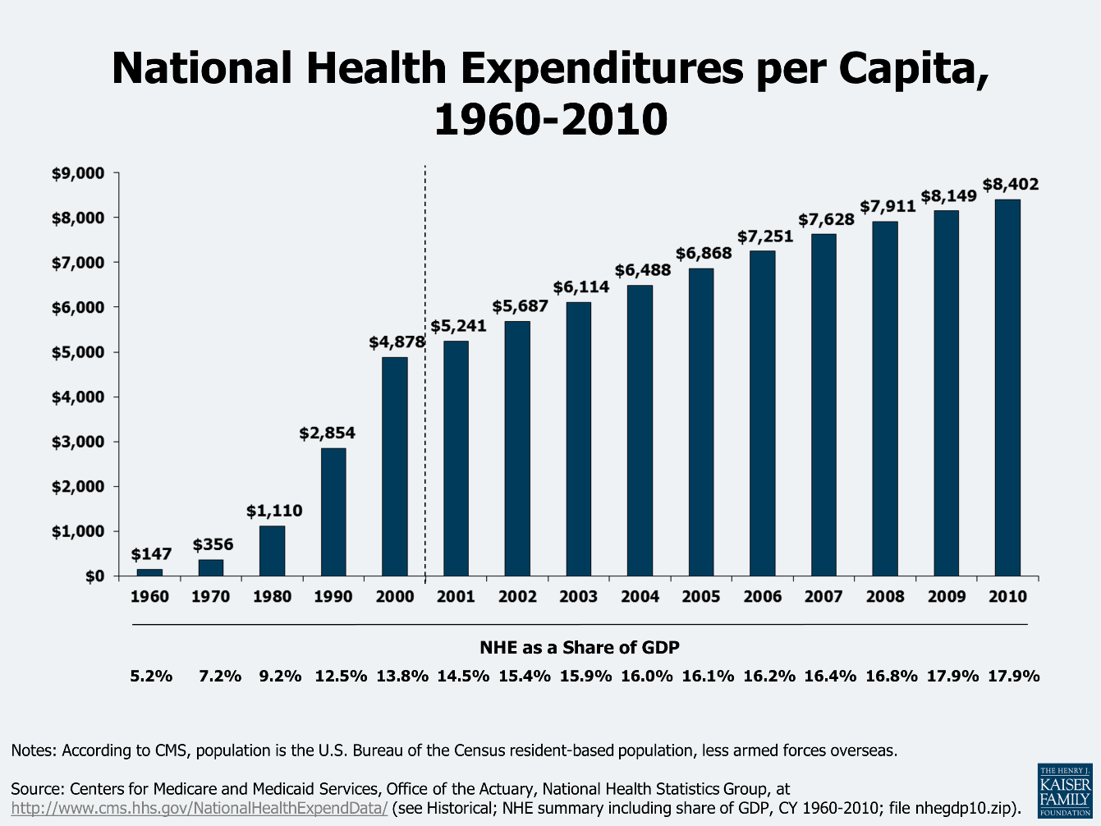

The data in the table is also segmented by different types of healthcare settings, such as inpatient and outpatient care, primary care, and specialty services. This segmentation allows for a more detailed analysis of how policy changes impact various segments of the healthcare system differently. For instance, changes in policy may have a more pronounced effect on outpatient care costs compared to inpatient care, reflecting differences in how services are delivered and billed. Another significant area covered in the table is the expansion of insurance coverage mandates.

Policies that require coverage for additional services or conditions, such as mental health care or preventive screenings, aim to enhance patient outcomes by ensuring broader access to necessary services. While these mandates are designed to address gaps in care and improve health outcomes, they often result in higher overall costs for insurers and healthcare providers. For insurers, the expansion of coverage can lead to increased claims and administrative costs, which are typically passed on to consumers through higher premiums and cost-sharing. This can create a financial burden for individuals, particularly those who are already economically disadvantaged. Furthermore, the added complexity of covering a wider range of services can strain the resources of healthcare providers, leading to increased operational costs and potential adjustments in service delivery. Moreover, the table highlights how changes in regulatory requirements, such as new reporting standards or compliance measures, can impact healthcare costs. Compliance with these regulations often necessitates additional administrative work, investment in new technologies, or staff training, all of which contribute to higher operational costs for healthcare facilities. These increased costs can be reflected in patient charges or reduced availability of services. On the other hand, effective regulatory measures can improve the quality of care and operational efficiency, potentially leading to long-term cost savings despite the initial investment.

Additionally, the table explores the impact of policy changes on specific types of healthcare services, such as preventive care, chronic disease management, and emergency services. Each of these service areas can be differently affected by policy changes, with varying implications for costs. For example, policies that emphasize preventive care can initially increase costs due to the need for more screenings and interventions but may lead to significant cost savings in the long term by reducing the incidence of severe health conditions and related treatments. Similarly, changes in how chronic diseases are managed or how emergency services are funded can affect the financial dynamics of these care areas, influencing both provider costs and patient expenses. In summary, the table provides a detailed analysis of how various policy changes affect healthcare costs through multiple mechanisms, including adjustments in reimbursement rates, expansion of insurance coverage mandates, regulatory compliance requirements, and the impact on specific service areas. Understanding these dynamics is crucial for stakeholders aiming to navigate the complexities of healthcare finance and to develop strategies that balance cost management with the goals of improving patient care and access.

**Hospital Care:** Hospital care is one of the largest categories of healthcare spending. This includes expenditures on inpatient and outpatient hospital services, emergency care, surgical procedures, and diagnostic tests. Hospital care spending is influenced by factors such as the number of hospital admissions, the complexity of treatments, and the cost of hospital infrastructure and staffing. In 2022, hospital care continued to be a significant driver of healthcare spending. The ongoing effects of the COVID-19 pandemic contributed to increased hospital admissions and expenditures related to the treatment of COVID-19 patients, including the costs of ICU care, ventilators, and specialized treatments.

**Physician and Clinical Services:** Expenditures on physician and clinical services encompass payments for office visits, consultations, diagnostic tests, and minor surgical procedures performed by healthcare providers. This category also includes spending on primary care, specialty care, and preventive services. The rise in spending on physician and clinical services in 2022 was influenced by factors such as increased utilization of healthcare services, the expansion of insurance coverage, and the growing complexity of medical care. Additionally, the increased use of telemedicine and virtual consultations added a new dimension to this expenditure category.

**Pharmaceuticals:** Pharmaceutical spending includes expenditures on prescription drugs, over-the-counter medications, and vaccines. This category has been a significant contributor to overall healthcare spending, driven by factors such as the introduction of new medications, the cost of specialty drugs, and the growing prevalence of chronic diseases. In 2022, pharmaceutical spending saw continued growth due to the development and distribution of COVID-19 vaccines, as well as the high costs associated with innovative therapies and treatments for chronic conditions. The rising cost of prescription drugs remains a major concern for policymakers and consumers alike.

**Long-Term Care:** Long-term care expenditures include spending on services such as nursing home care, home health care, and assisted living facilities. This category primarily serves the elderly and individuals with chronic conditions who require ongoing assistance with daily activities. The aging population and increasing prevalence of chronic conditions contributed to higher spending on long-term care in 2022. Efforts to improve the quality of long-term care services and address workforce shortages in this sector were also factors influencing expenditure levels.

**Public Health Programs:** Public health programs encompass spending on disease prevention, health promotion, and community health initiatives. This includes funding for vaccination programs, health education campaigns, and public health research.

In 2022, investments in public health programs continued to be important for addressing the ongoing impacts of the COVID-19 pandemic and improving overall population health. Funding for public health initiatives aimed at reducing health disparities and promoting preventive care was a key area of focus.

**Implications of National Health Expenditure**

The implications of National Health Expenditure extend beyond the immediate financial impact. Understanding these implications is essential for policymakers, healthcare providers, and consumers:

**Financial Sustainability:** High levels of healthcare spending raise concerns about the financial sustainability of healthcare systems. Managing expenditures while ensuring access to high-quality care is a critical challenge for policymakers and healthcare administrators.

Efforts to improve efficiency, reduce waste, and optimize resource allocation are essential for ensuring the long-term sustainability of healthcare systems. Value-based care models and payment reforms are examples of strategies aimed at improving the efficiency of healthcare spending.

**Access to Care:** National Health Expenditure has a direct impact on access to healthcare services. Adequate funding for healthcare services ensures that individuals can access necessary treatments and preventive care. However, disparities in spending and access to care can exacerbate health inequities. Addressing these disparities and ensuring equitable access to care is a key consideration for policymakers and healthcare providers.

**Economic Impact:** Healthcare spending has broader economic implications, including its impact on employment and economic growth. The healthcare sector is a significant source of jobs and contributes to economic development through investments in infrastructure and technology. Balancing the economic benefits of healthcare spending with the need to control costs is a key challenge. Policymakers must consider the broader economic impact of healthcare expenditures when making decisions about funding and resource allocation.

**Trends and Future Directions**

Looking ahead, several trends are expected to shape National Health Expenditure:

**Increased Focus on Preventive Care:** There is a growing emphasis on preventive care and health promotion to reduce the incidence of chronic diseases and improve overall health. Investments in preventive services and health education are expected to play a key role in shaping future spending trends.

**Expansion of Value-Based Care:** Value-based care models, which focus on improving patient outcomes and reducing costs, are likely to become more prevalent. These models aim to align incentives with the quality of care delivered, potentially leading to more efficient spending.

**Technological Integration:** The continued integration of technology in healthcare delivery is expected to influence spending patterns. Innovations such as telemedicine, AI, and digital health tools have the potential to improve care and reduce costs but require ongoing investment.

**Policy and Regulatory Changes:** Ongoing policy and regulatory changes will continue to impact National Health Expenditure. Efforts to control costs, improve transparency, and expand coverage will shape future spending patterns and healthcare delivery.

***Thank You.!***